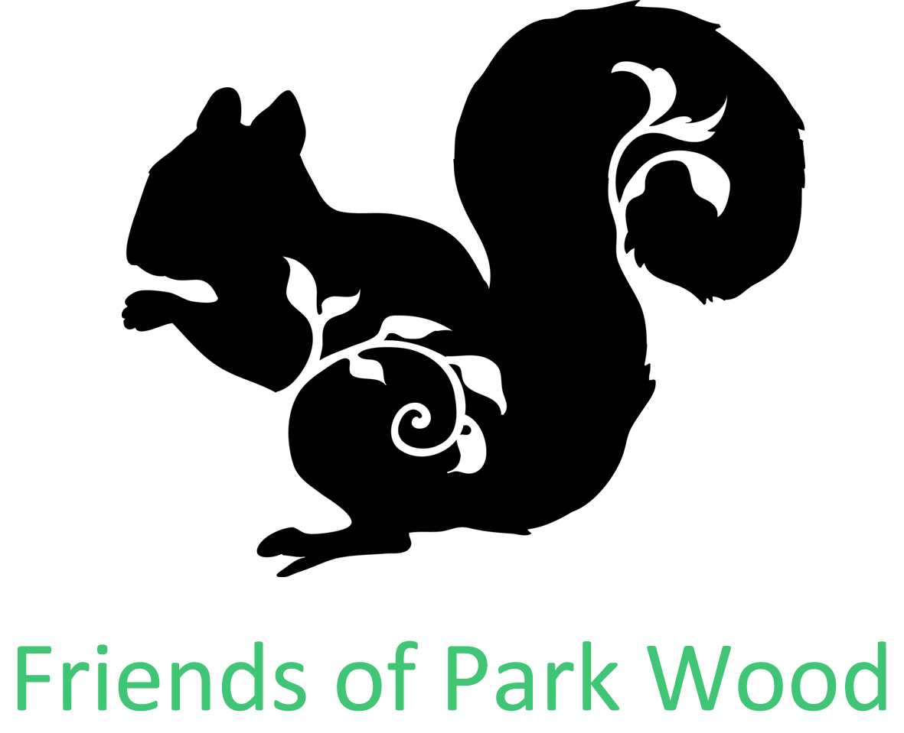
Friends of Park Wood Annual General Meeting
28 February 2018
PR & Marketing Report

2017 was a good year regarding public relations, partnerships and getting our name out there.

During 2017:

- A programme of events was put together for 2017 including a dawn chorus bird walk, fungus foray, family social event and archaeological talk

- Other events that took place in Park Wood that we helped promote were Get Out More Forest Schools and activities and a Big Local, Winter Celebration

- Regular visits to the website were gained – average of 48 active visitors a month

- We were donated bird boxes from Axial Pest Control.

- Partnerships were developed with Big Local and Get Out More

- Gained a new partnership with Pennine Prospects and Chris Atkinson. Park Wood was one of the locations for a woodland archaeological survey.

- We took part as a participating organisation in The Challenge, a National Citizen Service project that helps young people learn new skills, gain confidence and meet other young people. Young people from The Challenge helped FoPW at our family social event in August and ran activities, fundraised and took part in the social event.

- We regularly attended the Green Spaces Keighley meetings for friends of parks, woodlands and other green spaces. Groups can update on news and share ideas and concerns.

- We attended a BMDC Regulatory and Appeals Committee meeting at City Hall, Bradford, where our Chairperson, Eric spoke in opposition to a strip of Park Wood land being sold at the bottom edge of the woodland. The committee agreed to sell the land to a local business, subject to:

- to the implementation of an approved tree planting scheme to screen the parking area and the provision of a new entrance into the woodland from Parkwood Street, at the expense of the purchaser.

- the imposition of a restrictive covenant that the land is not to be used for any activities that may cause nuisance or be detrimental to the use of the Recreation Ground

- and that the net proceeds (£5,000) be reinvested in the Parkwood Recreation Ground in consultation with the ‘Friends of Parkwood’.

- As a result of the opposition to the land being sold, Keighley News published an article highlighting Friends of |Park Wood as advocates for the wood.
Green Drinks

FRIENDS OF PARK WOOD MARKETING AIMS FOR 2018:

- BE AN ADVOCATE FOR PARK WOOD AND OTHER GREEN SPACES

- ENJOY THE WOODS AS A GROUP

- VISIT OTHER WOODS AND NATURAL PLACES AS A GROUP

- ENCOURAGE LOCAL PEOPLE OF ALL AGES TO ENJOY PARK WOOD AND LEARN ABOUT OUR LOCAL NATURAL URBAN ENVIRONMENT

France-Leigh Hadrysiak, Marketing & Communications Officer

